# CS 255 System Design Document

## UML Diagrams

### UML Use Case Diagram

### UML Activity Diagrams

1. *Student login  
   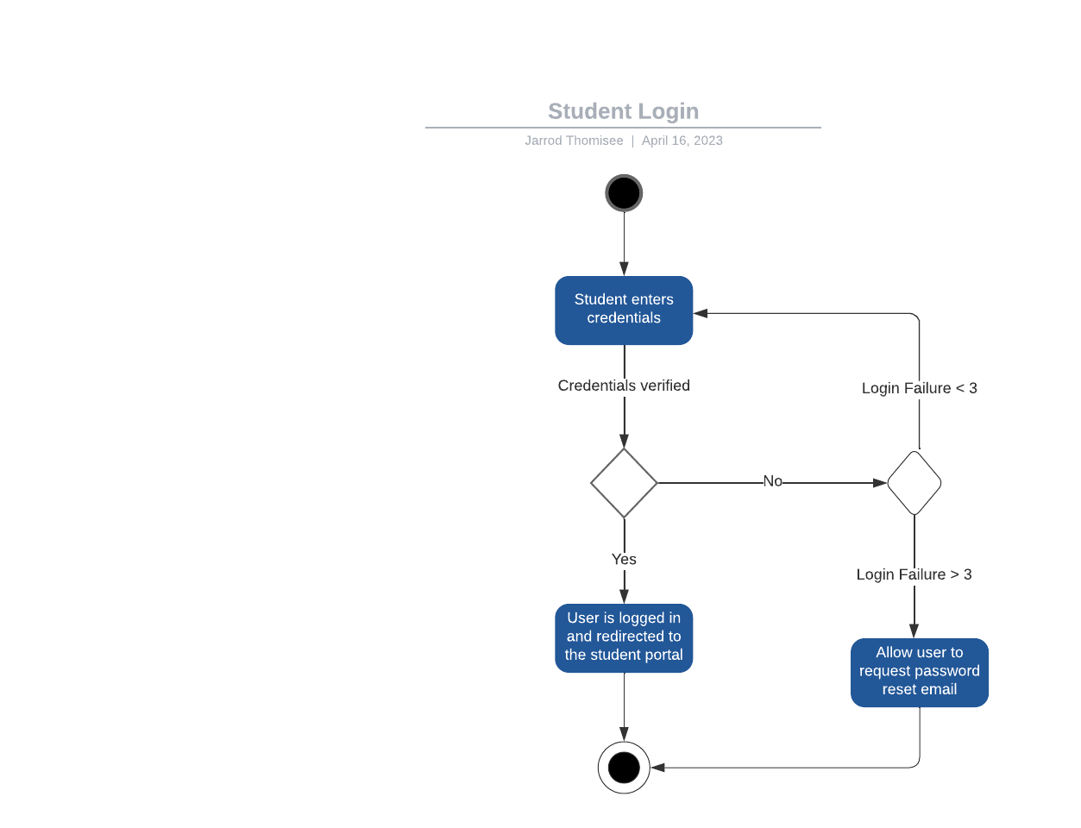*
2. *Admin Modify Student Accounts  
     
   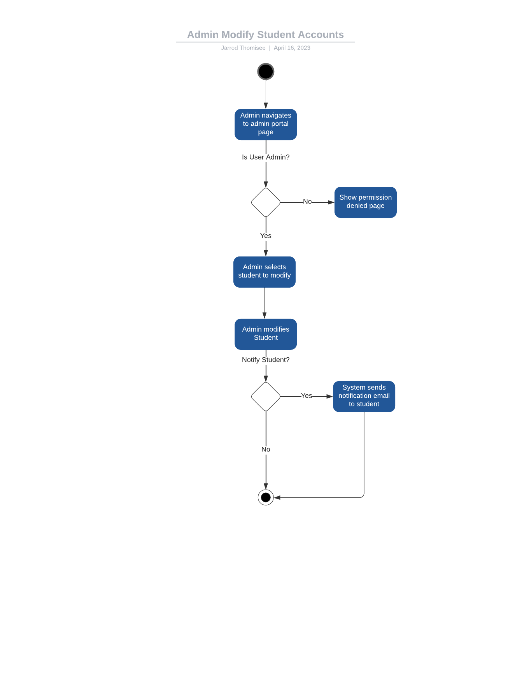*

### UML Sequence Diagram

### UML Class Diagram

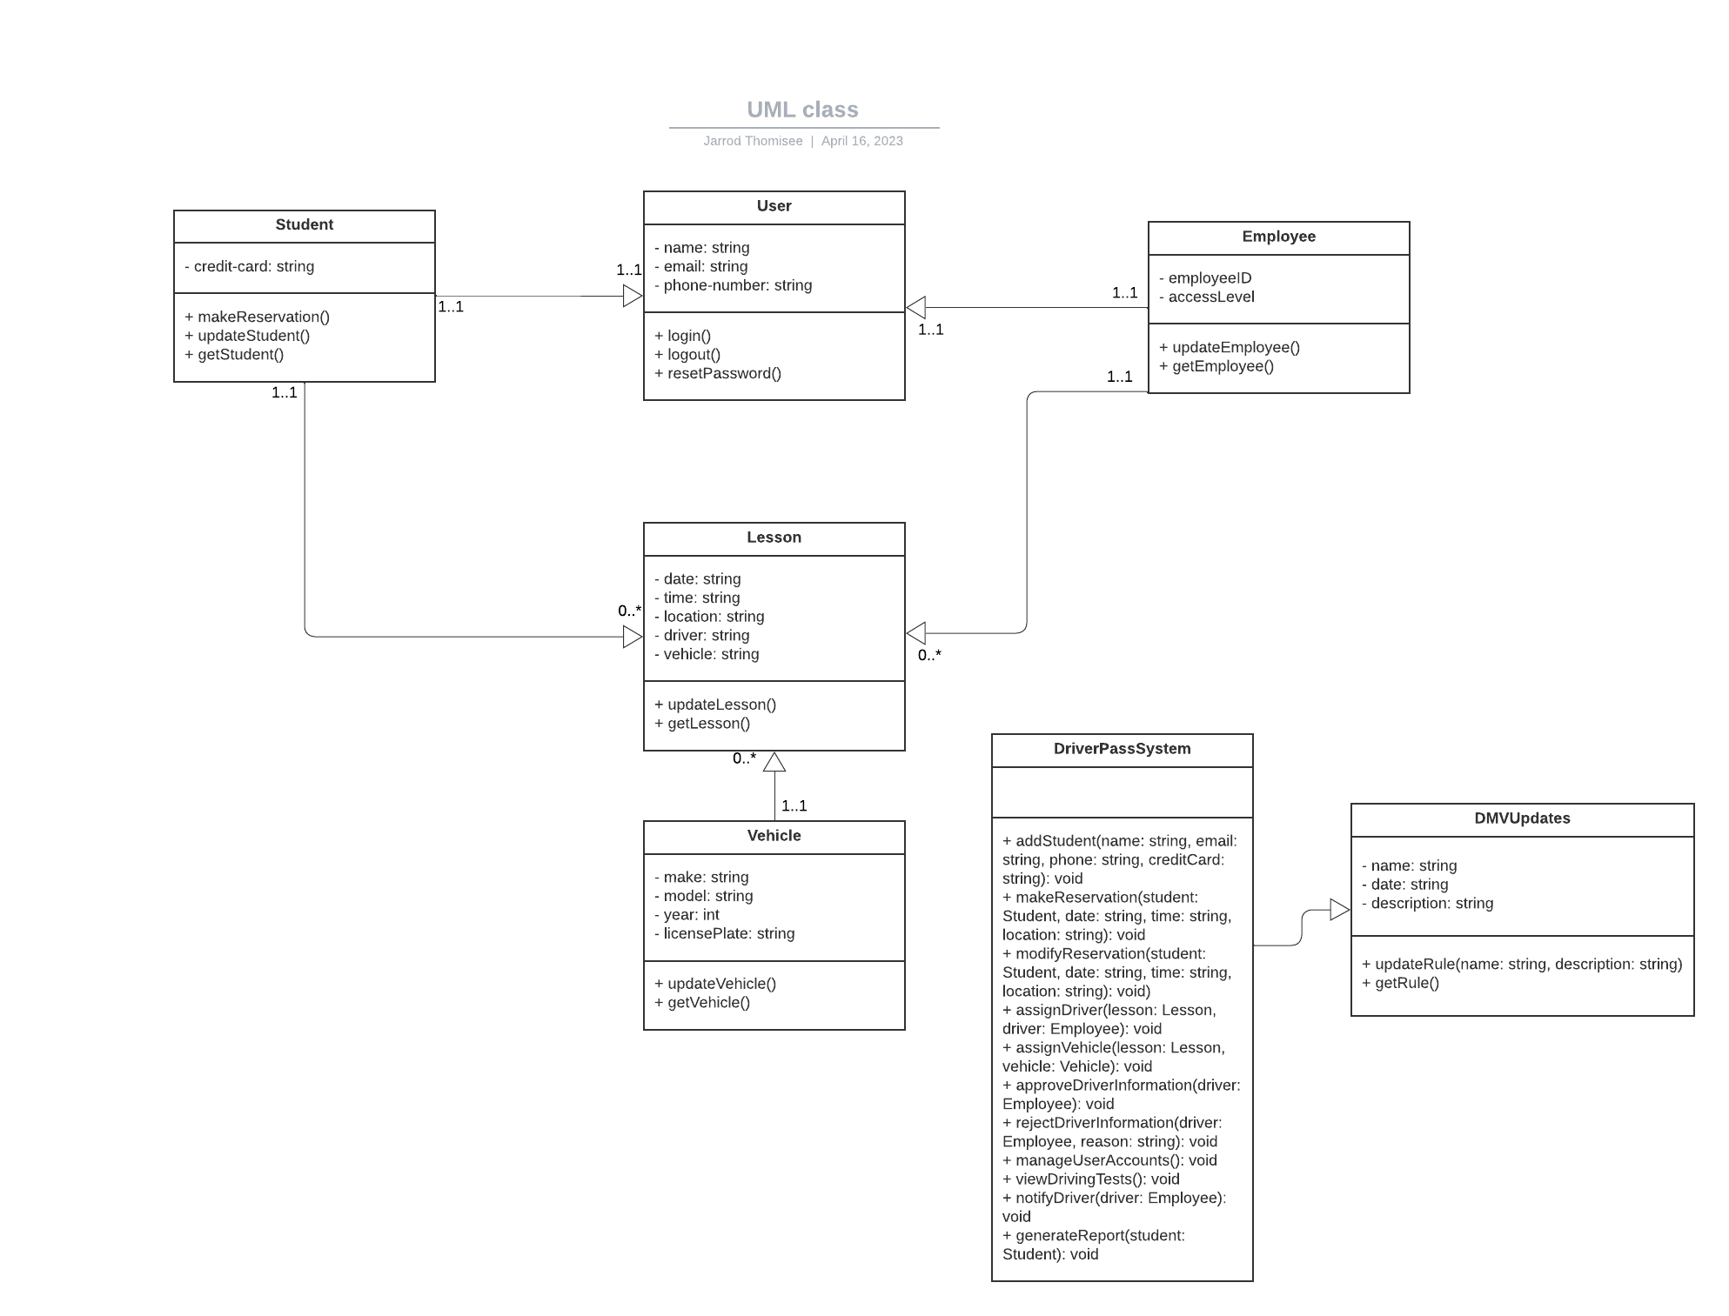

## Technical Requirements

* *Hardware:*
  + *Servers to host the system and databases*
  + *Workstations for employees and customers to access the system*
* *Software:*
  + *Programming languages and frameworks to develop the system*
  + *Database management systems to store and manage data*
  + *Web servers to host the system and provide access to users*
  + *Security software to ensure system and data security*
  + *Communication protocols for data exchange between different components of the system*
* *Tools:*
  + *Integrated development environment (IDE) for software development*
  + *Version control system for managing code changes and collaboration*
  + *Testing tools for system and integration testing*
  + *Monitoring tools to ensure system stability and performance*
* *Infrastructure:*
  + *Network infrastructure to connect all the components of the system*
  + *Cloud services or hosting providers to host the system and databases*
  + *Backup and recovery systems to ensure data is safe in case of disasters*